Upper Cumberland Bigfoot Festival
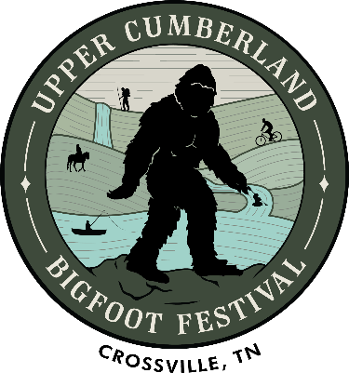
Sponsored by
Saturday, October 16th, 2021
Cumberland County Fairgrounds
1398 Livingston Rd. Crossville, TN
Gates open at 9:00 a.m.

Supporting Cumberland County United Fund!

Featuring the cast of Animal Planet’s Finding Bigfoot!
Cliff Barackman, Bobo, & Matt Moneymaker!
as well as
Comedian Mike Snider!

Axe throwing, Bigfoot calling, food, vendors, music & MORE!

$5 Adults & Kids 12 and under are FREE
More info at https://ucbigfoot.com/

